Membership Regulations

(Please read these Regulations and Guidance Notes before completing the application form)

General

1. All applications must be made on the relevant application form obtainable from the Institute.

2. Only applicants for Technical, Professional and Fellow grades need offer referees and details of career and education.

3. Subscriptions shall be paid annually on 1 July as determined by the Annual General Meeting of the Institute. Current rates are set out in the enclosed schedule.

4. Applications must be accompanied by a non-returnable Registration fee as set out in the schedule.

5. Every applicant shall submit with the application the first annual subscription. Applications submitted 1 Jan to 31 March need submit only half the annual rate plus the full Registration fee. Applications during April, May and June will be treated as being made on 1 July.

6. All grades of membership are awarded at the sole discretion of Council and may be withheld or withdrawn in the event of Council receiving evidence that the applicant or member has engaged in conduct likely in the opinion of Council to prejudice the standing of the Institute. These matters are regulated by the Institute's Code of Professional Conduct. Infringements of the Code may lead to withdrawal of membership.

7. Membership may be withdrawn in the event of the annual subscription being in arrears for three months and not being paid within three months of a written request. Once membership is withdrawn, certificates become invalid and must be returned to the Institute.

Regulations for the admission of Affiliates and Student Members

8. Subject only to Regulation 6, receipt of a properly completed application form, together with any appropriate fees, shall be all that is required to confer the status of Affiliate or Student member on an applicant.

9. Affiliates and Student members shall indicate on their application forms that they have an interest in the practice of Corrosion Technology, Engineering or Science and shall provide details of their age, address and current employment.

10. Student members shall apply for transfer to Affiliate or apply for professional grades of membership within six months of ceasing to be a student.

11. Affiliates and Student members shall not use any title or suffix to their names which might be intended to indicate that they are Professional Members of the Institute.

Regulations Regarding application for Professional Grades of Membership

A: Technician Member Grade

12. All applicants must demonstrate that they have been trained in and/or acquired competence/certification in painting and coating inspection, cathodic protection or other corrosion related fields.

13. Evidence of education, training, experience and achievements shall be submitted in the form of a Training and Experience Report (see Guidance Notes) in addition to a current CV, appended to the completed application form.

14. Requirements

- Applicants who have obtained certification at Level 3 Painting Inspector or Level 3 Cathodic Protection (ISO) or Institute Approved Equivalents shall be eligible for Technician Membership.
OR
- Applicants who have obtained certification at Level 2 Painting Inspector or Level 2 Cathodic Protection (ISO) or Institute Approved Equivalents shall be eligible for Technician Membership after completing the Fundamentals of Corrosion Course or approved equivalent and 3 years of verifiable field experience.
OR
- Applicants who can demonstrate that they have 8 years verifiable experience as a Corrosion Practitioner may be admitted after completing the Fundamentals of Corrosion Course or approved equivalent.

15. An applicant for election to Technician Membership must supply the names of two referees both of whom should be Professional Members of the Institute and at least one of whom should have a detailed knowledge of the applicant's professional/industrial experience.

16. Persons elected to this grade are entitled to use the letters TICorr after their name.

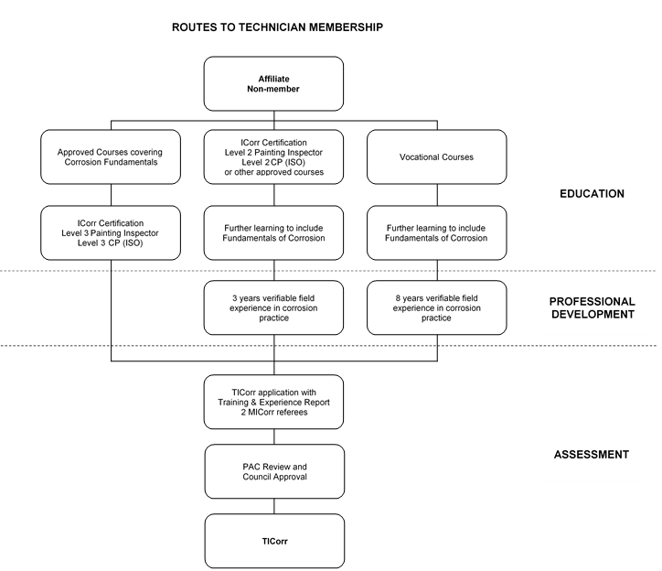

B: Professional Member Grade

17. All applicants must demonstrate that they have been trained in and/or acquired competence as corrosion scientists, corrosion technologists, corrosion engineers or other corrosion practitioners. Applicants must demonstrate that they have a sound understanding of the fundamentals of corrosion.

18. Evidence of education, training, experience and achievements shall be submitted in the form of a Training and Experience Report (see Guidance Notes), in addition to a current CV, appended to the completed application form. This should emphasise the level of responsibility enjoyed and detail the precise nature and duration of tasks performed.

19. An applicant for election to Professional Membership must supply the names of two referees, both of whom should be Professional Members of the Institute and at least one of whom should have a detailed knowledge of the applicant's professional/industrial experience. In certain cases, the Institute may be prepared to waive the requirement that both referees need to be Institute of Corrosion Professional Members where the referee having a detailed knowledge of the Applicant's professional/industrial experience is a Professional Member of another approved professional Institute.

20. Requirements

A. Applicants who possess an appropriate post-graduate qualification will be admitted after they have completed one year’s approved experience. An appropriate post-graduate qualification would normally involve possession of a higher degree in the physical sciences, engineering or metallurgy with an appropriate corrosion science and technology content.
OR
B. Applicants possessing a suitable degree or equivalent qualification at Higher Education Level 3 or 4 such as corporate or professional membership of an approved Professional Institute, or having a general education up to the level of Higher Education Level 2 (i.e. Higher National Certificate/Diploma) in physical sciences or metallurgy, will be admitted after they have completed three years' approved experience in corrosion practice.
OR
- Applicants who do not possess appropriate academic qualifications but who have been engaged in corrosion technology for at least fifteen years, of which a substantial part has been in an important position of responsibility, will be admitted after they have reached the age of 35 years.

21. Persons elected to this grade are entitled to use the letters MICorr after their name.

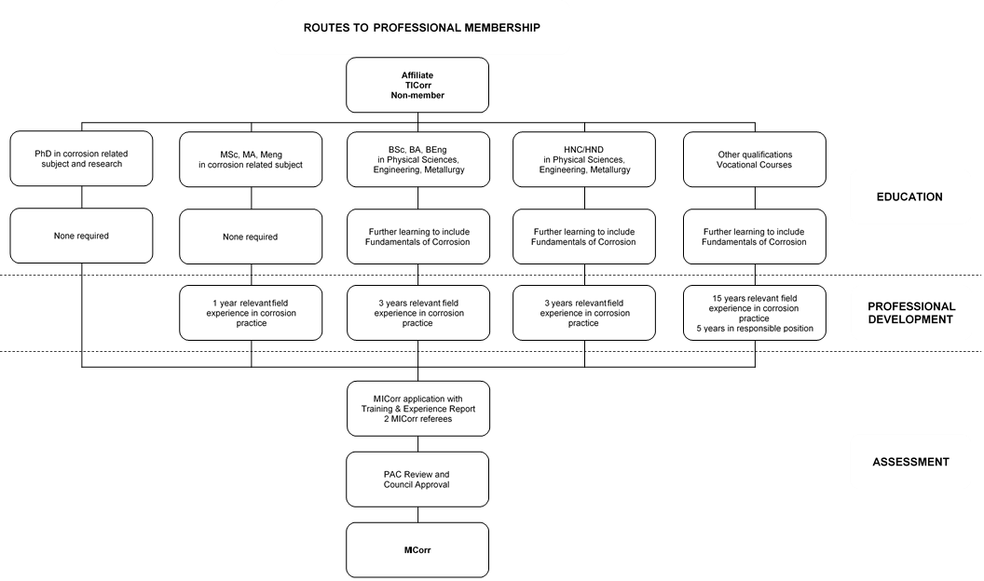

C: Fellow Grade

22. Applicants for Fellow grade shall supply the names of two other Fellows of the Institute as referees. In exceptional circumstances, one referee may be a Fellow of another approved professional Institute who is familiar with your work and experience.

23. The Experience Report (for the period of time following award of Professional Membership) should establish your mature reputation as a corrosion practitioner or the marked and original contribution to the science and practice of corrosion control of the applicant in one of the following categories:

24. Requirements

A. Applicants for this grade have made a marked and original contribution to the science and practice of corrosion control. Full evidence of this should include published papers, books, patents and presentations to the international corrosion community.
OR
B. Applicants for this grade have rendered special services to the Institute. This may be considered as follows:
1) a committee chairman for a minimum of 2 years or
2) a member of Council for a minimum of 5 years, preferably in a nominated role, or
3) special service at Branch level for a minimum of 5 years and
4) MICorr for a minimum of 7 years
OR
C. Applicants for this grade must have an established and mature reputation as a corrosion practitioner. This may be considered as being:
1) In the corrosion industry for a minimum of 15 years and in a senior position of responsibility as a corrosion practitioner for a minimum of 5 years
2) MICorr for a minimum of 7 years (or equivalent experience for non-members)
3) Author/presenter of a number of technical papers
4) Recognised as a corrosion specialist by your peers

25. Persons elected to this grade are entitled to use the letters FICorr after their name.

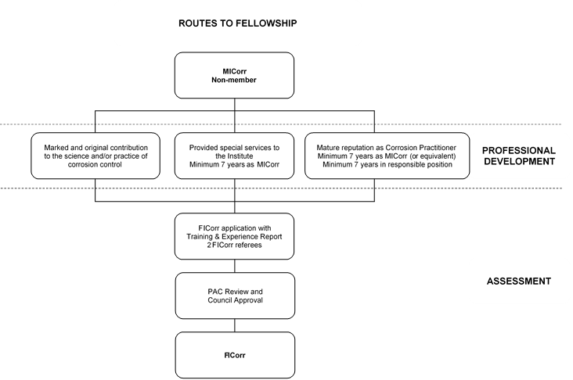

Guidance Notes
For Completing Application Forms for Professional Grades of Membership

(Please ensure that you have read and understood the Membership Regulations)

- CATEGORY OF MEMBERSHIP. If you are applying for admission as a Student or Affiliate, different procedures apply. Please ask for the appropriate form. Referees are not required.

B. REFEREES. Your referees, who should be Professional Members of ICorr, should be approached when your application is complete. They are advised to read and agree the content before endorsing your application including attached CV and Training and Experience Report and copies of certificates signed by the applicant and at least one referee.

In some geographical areas, there may be difficulties in finding Professional Members of the Institute who can speak knowledgeably about the applicant's industrial experience. In cases where Institute Members cannot be found to act as referees, it is accepted that corporate members of other professional bodies, comparable in status to the Institute, may know the applicant well and be willing to act as referee (see note D below for examples of acceptable bodies). For applications to Member grade, the Professional Assessment Committee is prepared, in certain cases, to waive the regulation that both referees should be either Members or Fellows of this Institute and accept alternative referees.

Referees will be required to complete a confidential referee report, which will be sent to them when your application has been received by the Institute. The Professional Assessment Committee attaches considerable importance to the statements made by referees in supporting applications for professional membership.

C. EDUCATION. List here full details of attainments in further and higher education at college or university. If you lack such academic qualifications, please give full details of secondary school examinations. Copies of certificates, signed by the applicant and at least one referee, should be enclosed (see note K).

D. PROFESSIONAL QUALIFICATIONS. Examples of suitable professional bodies are the Royal Society of Chemistry, Institute of Materials, Minerals and Mining, Institute of Physics, Institute of Metal Finishing, and the Institutions of Civil, Mechanical, Chemical, Electrical or Production Engineers. Copies of certificates showing professional qualifications awarded by these bodies should be enclosed (see note K).

E. KNOWLEDGE OF CORROSION FUNDAMENTALS. (Regulation 17) The application must show that a sound knowledge of corrosion fundamentals and corrosion control has been attained. This could include attendance at appropriate courses, diversity of work experience in corrosion control, etc. Without this, the application is unlikely to be accepted.

F. PUBLICATIONS AND REPORTS. Please give date and titles of published works, indicating joint authorship where appropriate. It is preferable to send copies of published papers or articles since their technical content can vary considerably. Please ensure that the name of the journal and its date of publication are stated. Applicants for the grade of Fellow are asked to supply a copy of their most important publications in support of their application. All publications will be returned at the conclusion of the Professional Assessment Committee procedure, if requested.

G. UNPUBLISHED WORK. Please give details and titles of unpublished papers and lectures, inventions, patents and works of special interest and value, or any other information you may consider relevant. Where publication has been restricted, if possible, give the name and address of somebody in authority who can verify the type of work undertaken. All publications will be returned at the conclusion of the Professional Assessment Committee procedure, if requested.

H. APPLICATIONS FOR PROFESSIONAL MEMBER (MICorr). Regulations governing admission to the professional grade of Member allow for the election of mature applicants with considerable professional experience in corrosion technology but who may lack the required academic qualifications. Purely commercial interest in this field is NOT regarded as professional experience in this context. Your CV and Training and Experience Report are the main source of information from which the Professional Assessment Committee can judge the relevance and importance of your work and ensure that it complies with the requirements of the Regulations. If you have any other relevant information you think may be of use to the Committee which is not covered by the application form (for example, services to the Institute or other bodies) use a separate sheet.

- CURRICULUM VITAE. In your CV, list the items in reverse chronological order, starting at present, and give name and address of employers, nature of appointments, nature of business, appointment from/to dates, number and grade of technical staff (citing appropriate qualifications) under your supervision and to whom you report, type of work involved and degree of responsibility. Early appointments should particularly indicate any apprenticeship or practical field training, and indicate the depth and breadth of experience in corrosion technology or science. Evidence of Continuing Professional Development should also be given.

- APPROVED TRAINING AND EXPERIENCE REPORT. For admission to Professional Membership of the Institute, you must be able to demonstrate, not only that you have acquired a knowledge of the fundamental principles of corrosion and corrosion control, but also that you have received training in the skills and duties of a corrosion scientist, engineer, technician or other practitioner and have obtained sufficient experience and borne sufficient responsibility to fulfil the requirements of the Institute.

The Membership Regulations specify education, training and experience requirements and you are required to submit
acceptable evidence of this. The Professional Assessment Committee appreciates that the preparation of an attested, narrative Training and Experience Report of some 1–2 pages might be seen by many prospective Professional Members as a daunting task (PAC are not looking for an autobiography). The following explanatory notes are only intended to make it easier. Applicants who understand the purpose of the Report should have less difficulty in presenting the relevant information in a clear and concise manner.

The following suggestions are offered for guidance:

- All applicants must provide an attested Training and Experience Report containing, in narrative form, an account of the applicant's education, training and experience. Note: a CV does not usually provide the right information and should be provided as complementary to the Training and Experience Report.

2. The Attester, who should ideally be one of your Referees, should be a professionally qualified person who knows you and your work well and preferably is a Professional Member (MICorr or FICorr) of the Institute.

3. The Attester must append a statement to the effect that he has read the Report and it is an accurate statement.

4. If the Attester is related to you, the relationship must be stated.

5. The Report should demonstrate that you not only understand the fundamental principles of corrosion and corrosion control but also have an appreciation of the role and place of corrosion prevention and corrosion studies in Industry and Society.

6. The Report is an opportunity to inform the Institute how you obtained your understanding of corrosion fundamentals, how you received your industrial training and what your experience has been.

7. Write the Report in the first person singular in narrative form.

8. Present the report on A4 paper, typed with an adequate margin on either side.

9. Adequate descriptions of education, training and experience are unlikely to be given in less than one page. More than two pages is likely to be excessive.

10. Note carefully the requirements stipulated for age and number of years of experience in the Membership Regulations and be careful to clarify that all these requirements are demonstrably fulfilled according to the educational qualifications held.

11. Applicants who have not received a formal higher education may provide evidence that they have acquired an understanding of the fundamentals of corrosion by attendance certificates from approved short courses, reference to relevant publications bearing their name as author, by interview or by any other means that Council may approve.

12. The requirement that Professional Members have an understanding of the fundamentals of corrosion and corrosion control cannot be waived. You are not expected to demonstrate competence and ability in all branches of corrosion and its control, nor are you expected to be an expert in any particular field of corrosion, but you are expected to have sufficient grasp of the fundamentals to be able to understand your limitations, to be able to access the right expertise and to be able to give proper instructions and reports.

The Attested Report will be the main information upon which the application is assessed and that the membership requirements have been properly met. If clarification is required, this may be sought and in some cases, an interview may take place.

- DOCUMENTARY EVIDENCE. Copies of birth certificate and qualifications etc. may be appropriately attested by the signature of one of the referees. Originals need not be sent. Publications and reports will be returned, on request, after consideration by the Professional Assessment Committee.

- FEES. With the application form, you must send a non-returnable registration fee (see accompanying schedule), together with the appropriate subscription fee OR the difference between present membership grade and upgrade membership grade subscriptions. There is provision for payment by credit card: please enter the sums and total, and sign and date the completed authorisation.

- APPEALS PROCEDURE. An unsuccessful applicant may appeal in writing to the Chairman of the Professional Assessment Committee. The appeal will be considered by the next scheduled meeting of Council. The decision of Council is final.

NOTE 1: Failure to comply with the Membership Regulations and the Guidance Notes could lead to delay in processing your application. If you have any queries about completing this application, please contact the staff of the Institute for assistance.
NOTE 2: The Professional Assessment Committee can judge your application only on the information you provide - too much information is better than too little!

