Quality Assurance and ICorr

At the Institute of Corrosion, we have always understood the importance of providing a high quality of service to our Members and Clients. We have therefore embarked on setting up a Quality Management System fully complying with ISO 9001:2015. This has also been a requirement by the Highways England.

Our Quality System has been audited by LRQA and is now accredited with meeting the requirements of the ISO 9001:2015 Standard as shown on the certificate below.

The QMS will be audited both internally and externally to ensure ongoing compliance with the Quality System and continuous improvement of our system.

Correx are also separately accredited to this standard for ICATS

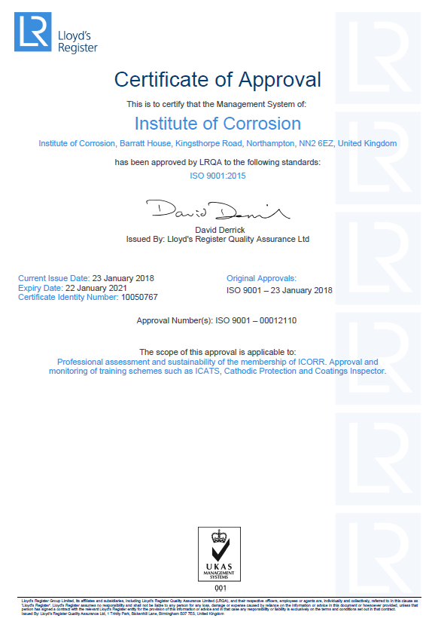
David Harvey, CEng, FICorr – Quality Assurance Adviser.

