Barratt House, Kingsthorpe Road, Northampton, NN2 6EZ
Tel: +44 (0)1604 438222
Email: admin@icorr.org Website: www.icorr.org

Dear Member,
The Trustees and Council of the Institute would like to invite you all to the 2017 AGM to be held on 29th November 2017 at the Council Chambers Birmingham in conjunction with a half day Midlands Branch meeting.

Midland Branch Meeting

12:30 - 13:30 Lunch served
13:30 - 13:40 Welcome and introductions
13:40 – 15:40 Presentations by industry experts
15:40 – 16:30 Panel discussion and Coffee Break
16:30 – 17:30 ICorr AGM

AGM Agenda
1 Apologies for absence
2 Minutes of the previous AGM November 2016
3 President’s report
4 Treasurer’s report
5 Elections
7 Any other business

The Trustees and members of Council will be available before the meeting to answer any questions you may have regarding the Institute and its future.
Again as in the case of 2016 the Institute’s accounts, and the minutes for the November 2016 AGM, will be available via the ICorr website (www.icorr.org). Please examine them and the website in general as we would appreciate your feedback. The website will continue to be influential in increasing the Professional Membership and the perspective of non-members of ICorr and as a major means of communication with membership.
Your confirmation of attendance or apology for absence will be appreciated preferably by e-mail to admin@icorr.org
We look forward to seeing you there.
Yours faithfully,
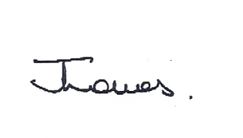
Dr Jane Lomas
Institute of Corrosion
Honorary Secretary

