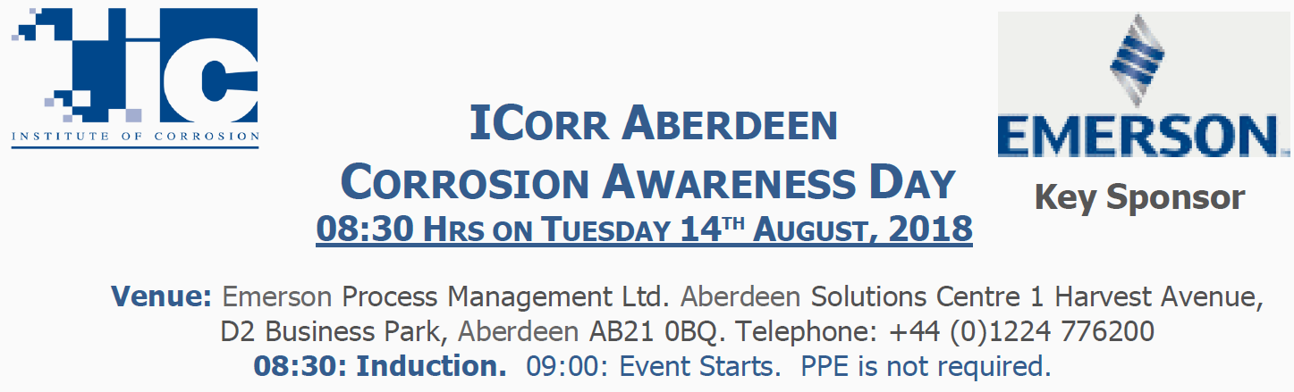

NAME:……………………………………………..
PLEASE COMPLETE ALL BELOW AND SCAN/E.MAIL BACK:
Stephen.Tate@external.total.com

Additional Information for Attendees:
- Age of Attendee………….
- Brief Educational Background / Qualifications……………………………………………………………….
- Please Indicate / Highlight, any Previous Knowledge of the Subject Matter to be INTRODUCED: (Corrosion Principles / Corrosion Costs / Modelling / Monitoring / Materials / Coating Selection / Cathodic Protection / Chemical Control / Bacterial Control / RBI / Inspection and Corrosion Management).
- Do you have any Personal Experience of a Corrosion Issue that you wish to share?
- Please elaborate for us…………………………………………………………………………………………….
- ………………………………………………………………………………………………………………………..
- Do you have any Special Dietary Requirement’s ? ……………………………………. …. Thank You.

We look forward to meeting you on the Day.

For Accommodation: we suggest Booking.Com (Hotels Dyce)
https://www.booking.com/searchresults.en-gb.html?aid=356980;label=gog235jc-airport-en-gb-abz-unspec-gb-com-L%3Aen-O%3AwindowsS7-B%3Achrome-N%3AXX-S%3Abo-U%3Ac-H%3As;sid=b0863c3112a58b98f57f0ca524d3dea9;city=-2595010

