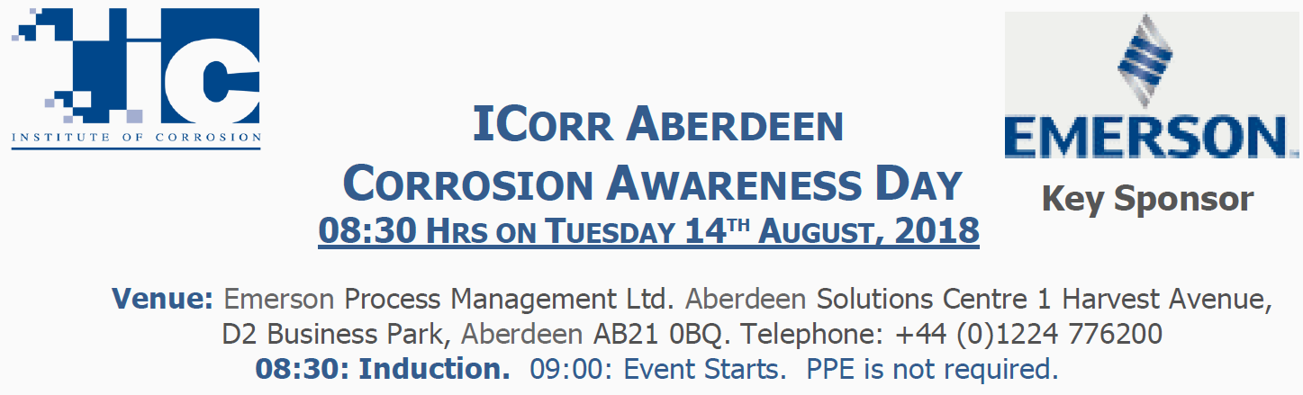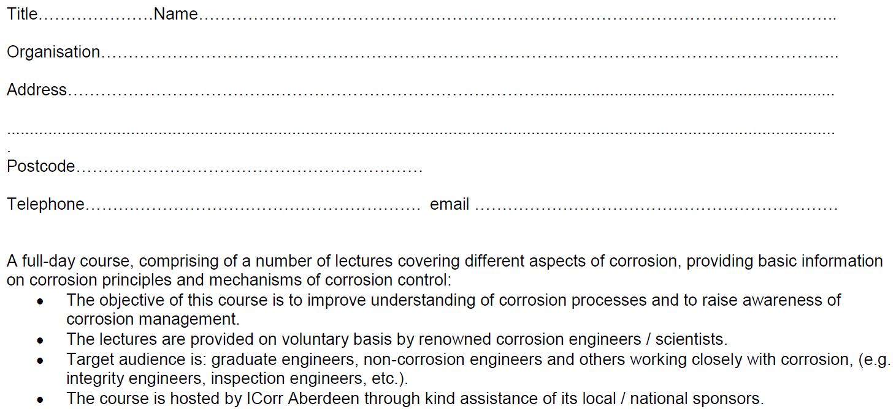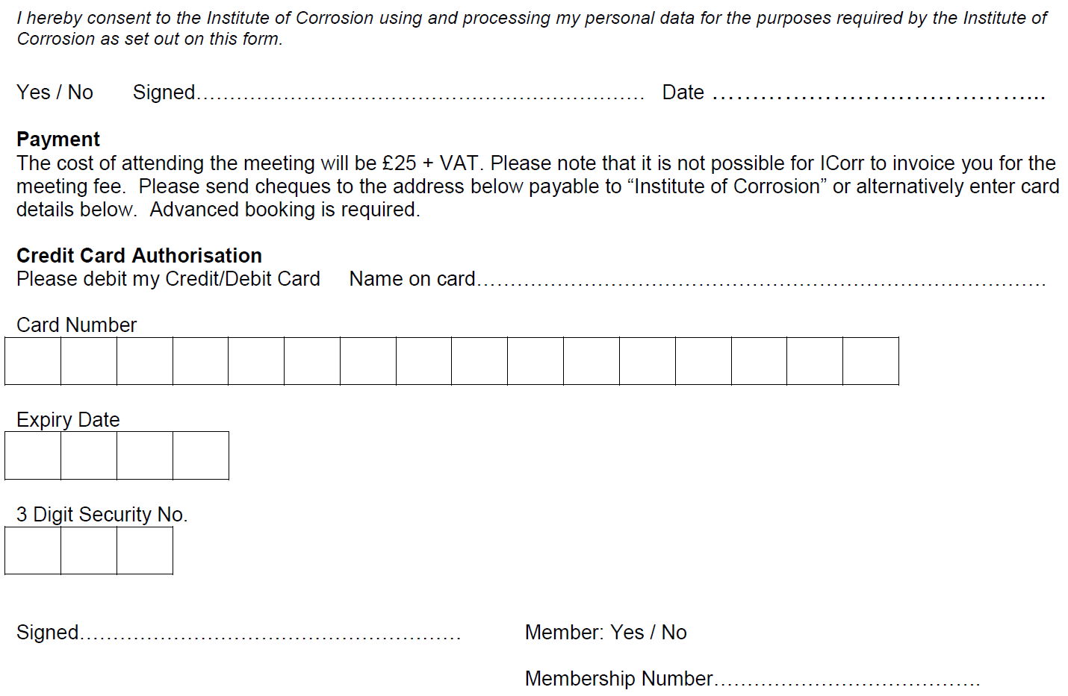

Conference Tickets are £49.00 + VAT.

* To Apply. Please e.mail completed form to: [admin@icorr.org](mailto:admin@icorr.org)
* Spaces are strictly limited and will be allocated on a ‘first-come first-served’ basis.