**Institute of Corrosion YEP Case Study:  
Onshore Titanium Pipe Corrosion Failure**

**Brief:**

Several leaks were experienced in titanium piping in an onshore glycol desalination plant which required further investigation.

The desalination plant is used to periodically remove the salts from mono-ethylene glycol (MEG) which is used for hydrate and corrosion control in gas pipelines from three offshore fields. A schematic of the onshore gas processing facility with the desalination plant is shown in Figure 1. The lean glycol product (this has had most of the water removed in the reboilers) is fed to the desalination plant as a dedicated stream or as a slipstream. When the desalination plant is offline or the salt concentrations are very high in the glycol stream (>10%wt), the product is usually sent offsite for desalination. Up to 70 trucks of glycol per week are sent offsite from the plant when required.



Figure 1: Process schematic of onshore gas processing facility

The onsite desalination plant is based around a vacuum distillation column (Evaporator) built predominantly with titanium. The capacity of the plant is ~9000 kg/hr lean glycol. The desalination plant is used to remove calcium ions and other salts from the dry glycol stream (on average by weight: 70% glycol, 20% water and 10% salts). A solution of hydrolysed

sodium carbonate is added to the dry glycol solution to ease preferential precipitation of calcium carbonate CaCO3 by ionic recombination. The plant is designed to handle 2.5 wt% solids (mainly sodium chloride) in the Evaporator. Sampling of the lean glycol indicated a salt content greater than 6.7 wt% is not uncommon. The process flow diagram is shown in the Figure 2.

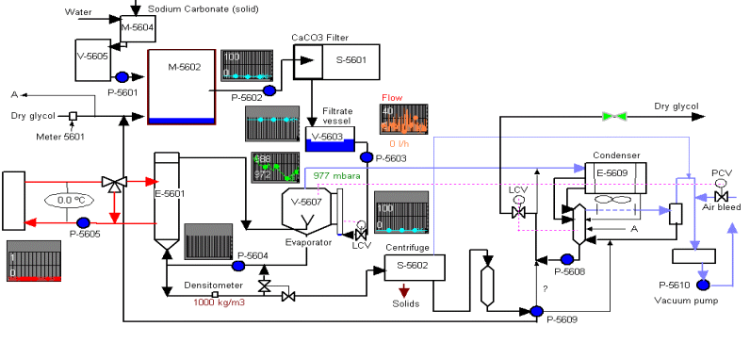

Figure 2: Process schematic of desalination unit

The leaking pipes were located in the Evaporator (V-5607) section of the desalination plant where salt (mainly sodium chloride) is separated from the lean glycol.

The Evaporator and associated pipework are fabricated with titanium. During the original materials selection Titanium Grade 1 and 2 were considered, but because of the acidic MEG, high salinity and high temperature (>100°C) in the Evaporator unit, Titanium Grade 12 was selected based on its enhanced corrosion resistance.

One leak occurred in a 28.5mm diameter pipe in the recycle line from V-5607 to the E-5601 Calandria (in the vicinity of a sampling point and pressure indicator).

Another leak occurred in a 33.4mm diameter 1.65mm thick pipe in the drain offtake from the Calandria to the S-5602 Centrifuge (Figure 3).

Figure 3. Leak in offtake line from E-5601

The pipes were ASTM Grade 12 titanium and in both cases the leakage occurred at a branch weld. The operating temperature of the piping was approximately 120°C (maximum 135°C). The fluid circulating inside the pipe was monoethylene glycol (MEG) containing sodium chloride (less than 25%wt). It was understood that organic acid might have formed in the solution. The pipes had been in service for 15 years. The pipes were insulated with a syatem of “Nilflame” & “Ulvashield”

**Initial examination:**

The leaking spool from the recycle line was subject to failure investigation. The sample investigated consisted of a pipe (28.5mm diameter), on to which two branches (same diameter) were welded. Each branch was welded perpendicularly to the ‘main’ pipe, forming a T-joint (Figure 4).

Figure 4. Spool from recycle line from V-5607

Near one of the T-joints, a hole (approximately 1mm in diameter) was visible (Figure 5). It was situated in the main pipe approximately 5mm from the toe of the weld. The insulation had been removed from the spool. The external surface was undamaged, apart from the hole.

Figure 5. Close up of leaking area in recycle line spool

**Exercise:**

1. Identify what further specific information you need and analyse/discuss in detail any results or data that you are provided with.
2. Propose credible root causes for the observed defects and describe the potential failure scenarios.
3. Explain how you would perform a corrosion risk assessment to determine if the plant is safe to operate. How would you determine the scope of the ongoing integrity surveillance plan and what would the scope include?
4. What mitigation options could be applied to prolong the service life of this section of the desalination plant? Critically review the list of mitigation options and present a case for the method(s) that should be implemented at site.
5. Propose alternative materials of construction for replacement pipe spools and describe the basis for the selection.
6. Describe what other factors should be considered in your assessment and propose possible longer term solution(s).