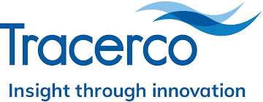
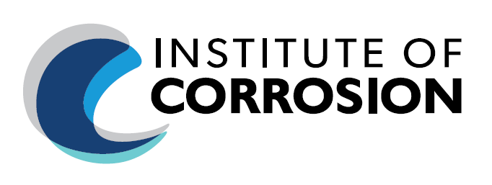

Institute of Corrosion (ICorr) Aberdeen Branch
Technical Meeting
Tuesday 23rd February 2021, Start Time: 18.00 (GMT).

This Webinar Event is free and open to all

Topic: Delivering Real Time Condition Monitoring of Subsea Pipelines

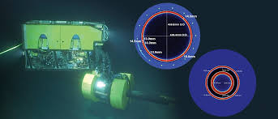

Speaker: Rob Hardy – Commercial Manager, TRACERCO

For registration: Please contact amirattarchi@gmail.com

Stating – Full Name, Company and ICorr Grade (if Applicable)

Event Programme:

17:50 – 18:00 Webinar Login
18:00 – 18:10 Introductions ICorr
18:10 – 19:00 Technical Presentations
19:00 – 19.20 Q&A Session
19:20 – 19.30 Closing Remarks ICorr.

About the Talk:

As assets age over time, oilfield professionals are continuously faced with the test of ensuring efficient production and pipeline integrity.

Inspection of pipelines subsea has often presented challenges where pigging is not an option or deemed too risky.

In this 3-part presentation, Tracerco will discuss the principles of collection of Integrity / Corrosion Data Subsea and various NDT principles deployed.

Inspection of pipelines subsea has often presented challenges where pigging is not an option or deemed too risky. Until now, inspecting a pipeline from the outside was costly and often an ineffective high-risk operation. DiscoveryTM has broken down this barrier to inspection by allowing online inspection of the pipe from the outside without removing the protective coating. DiscoveryTM has been created for flow assurance and integrity specialists concerned with subsea pipelines that cannot be inspected by conventional means such as ILI tools or on pipelines where operators want an alternative to the intrusion and loss of production ILI tools present, or validation of ILI results.

DiscoveryTM is a diagnostics instrument designed to detect wall loss, corrosion and build-up such as hydrate, sand, asphaltene, scale or wax. It can be deployed on piggable and unpiggable pipelines, online, without any interruption to production or the need for pipeline modifications. DiscoveryTM is deployed using an ROV and clamped onto the pipe. Real time communications allow instant assessment of pipeline conditions. Different versions are available based on pipe diameter and depth of deployment, and all are fully marinised.

Unlike alternative technologies such as ultrasonic and pulsed eddy current, using DiscoveryTM eliminates the expense and risk of damaging pipelines on coating removal/re-application.

Tracerco’s inspection services are used subsea to provide operators assurance of the integrity of their assets and to diagnose flow abnormalities. Understanding the production system and pipeline transport network is a key factor in safeguarding production processing and implementing appropriate remedial action. DiscoveryTM provides a high-resolution image of pipeline contents and pipe wall thickness, enabling pipeline integrity flaws and flow assurance conditions to be accurately visualised.

In this presentation, we will discuss example data obtained by DiscoveryTM via global pipeline inspection projects. This will include wall thickness mapping through concrete coatings, piggyback and pipe-in-pipe lines.

We will also discuss internal and external corrosion with recent examples of data obtained for clients.

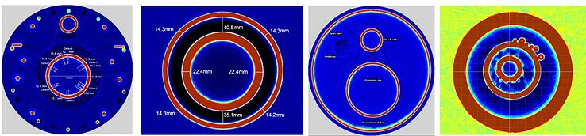

Finally, we will discuss more recent developments in the market such as;

- Fast screening with real time data to find points of interest.
- Baseline scanning to allow annual integrity scans on areas of concern.
Thermal expansion effects and fatigue.

About the Speaker:

Rob Hardy – Commercial Manager, TRACERCO

Has recently joined Tracerco from Oxford Instruments. Rob is keen cyclist and successful Charity Fundraiser. He has held several previous managerial positions in Industrial Scientifics Co’s including: CEM, Galen and Croda. Rob holds a Master’s in Chemistry from the University of Newcastle.

Tracerco is a world leading technology company, providing unique and specialised detection, diagnostic and measurement solutions. Our cutting-edge inspection services are used subsea to provide operators assurance of the integrity of their assets and to diagnose flow abnormalities. Understanding the production system and pipeline transport network is key to safeguarding production from reservoir to point of topside processing. Our subsea solutions offering include flow assurance, pig location and detection, asset integrity; flooded member inspection to unique and novel level measurements.
We can add value to your business by improving efficiency, reducing risk and saving money. As the world’s only subsea nucleonic instrument provider, our systems provide the optimum measurement solution for difficult process conditions, where the presence of extreme temperatures, pressures or abrasive and corrosive materials prevent the use of other technologies. These reliable and accurate instruments give clients a real-time, in-situ visualisation of their process conditions, ultimately providing the operator with insight onsite in subsea applications.

Every instrument is custom designed and tailored to each customer’s specific requirement.

Tracerco has played a central role in several high-profile subsea projects.

Web: www.tracerco.com
https://www.tracerco.com/services/subsea/asset-integrity/

ICorr Aberdeen Branch Sponsors
Without continued support from all our Sponsors, it would simply not be possible to provide our extensive Technical Programme to you.

To become a Sponsor – Please contact our New Sponsorship Officer:
Dr Olubayo Latinwo on ICorrABZ@gmail.com

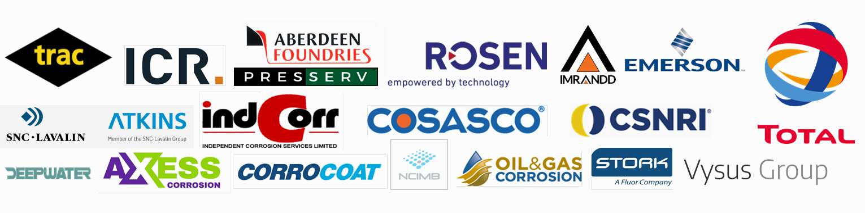

Why not join our growing community?

Could this be you?

