The Institute of Corrosion(ICorr), in a Registration Agreement Scheme with The Society of Operations Engineers (SOE), licensed by the engineering Council enables ICorr to offer registration as a Chartered Engineer, CEng with the Engineering Council (EC). The Engineering Council, in their “UK-SPEC -UK Standard for Professional Engineering Competence”, available on the ECUK website (www.engc.org.uk), sets the standard for this registration. The Institute of Corrosion has interpreted these and developed the Professional Competences required for registration which are given in the Appendix A.

Chartered Engineer is aimed at those practising engineering at the full professional level or at those for whom engineering knowledge or practice at that level form an essential element for the fulfilment of their role.

Chartered Engineers are concerned primarily with the progress of technology through innovation, creativity and change. They develop and apply new technologies, promote advanced designs and design methods, introduce new and more efficient production techniques and marketing and construction concepts, and pioneer new engineering services and management methods. They may be involved with the management and direction of high risk and resource intensive projects. Professional judgement is a key feature of the role, allied to the assumption of responsibility for the direction of important tasks, including the profitable management of industrial and commercial enterprises.

The award of Chartered Engineer (CEng) sets the individual practitioner at a high level of their profession. It demonstrates the achievement of a high-level education, the ability to practise the profession at a significant level and the maintenance and continued progression of engineering competencies and abilities. Becoming a Chartered Engineer carries considerable prestige and indicates to future clients, employers, colleagues and the public as a whole that you are a senior leader in your field of engineering and technology.

The Standard Route

The Standard Route to full registration consists of the educational base, followed by initial professional development, and finally the professional review. The academic benchmark which has been set by the Engineering Council for CEng is an accredited four-year integrated MEng degree, or a Bachelor’s degree which is accredited for CEng with further learning, plus an appropriate accredited Master’s degree.

The Individual Route (Technical Report Option)

For those Candidates who do not hold an accredited degree, the Individual Route is a means by which you can demonstrate that your knowledge and understanding of engineering principles meets the educational base requirements set by the Engineering Council. This educational base requirement needs to be confirmed as having been satisfied before you are eligible to proceed to Professional Review. The Individual Route may be required to produce a Technical Report.

These routes are indicated in the chart below:
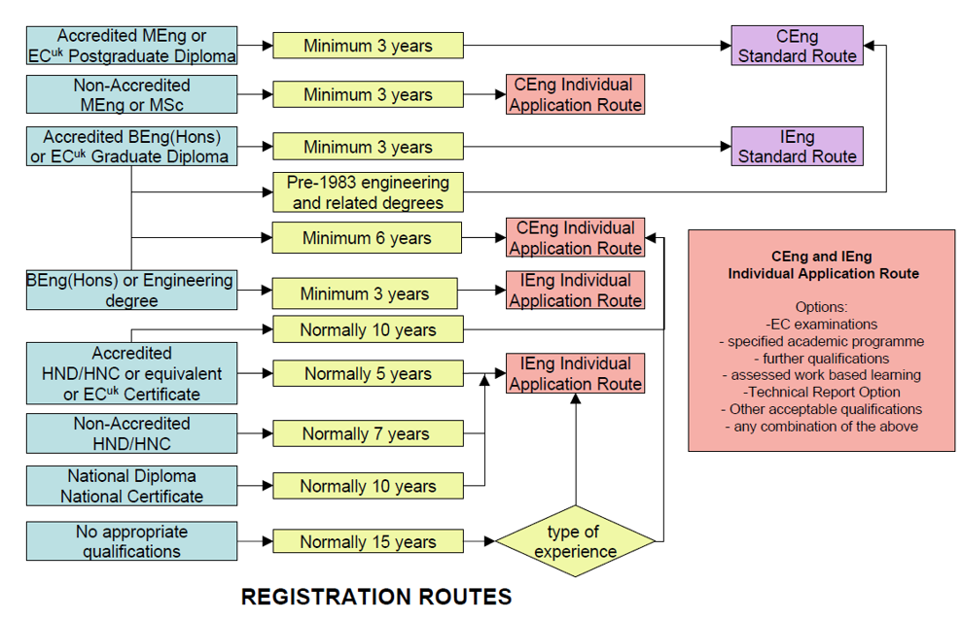
Candidates for CEng must be able to demonstrate their professional engineering experience as well as managerial skills. They must have practical knowledge and understanding of corrosion engineering, control or prevention and the underpinning engineering principles. They must also be able to exercise competent managerial skills and judgements.

Candidates will be assessed against the following competence statements as set down in UKSpec.

Competence | A | Knowledge and Understanding
 | B | Application to Practice
 | C | Technical and Commercial Leadership
 | D | Interpersonal Skills Commitment
Commitment | E | Personal Commitment

Health and safety, risk assessment, and understanding of the environment and sustainability are important and are embedded within the competences.

Therefore it is suggested that, before you make your application, you read the Engineering Council UK Spec www.engc.org.uk/ukspec , the Professional Competence statements (Appendix A) and complete the enclosed self-assessment checklist (Appendix B). This should help you identify any areas that may require further training or experience before you make your application. (It is also recommended that, where possible, you complete the checklist with your Sponsoring Referee.)
In addition, there are a number of stages in your development that need to be achieved:
- Educational Base

The exemplifying academic qualification is an accredited Master of Engineering (MEng) degree.

Eng (Hons) courses will be able to meet the accreditation requirements for CEng Interim Stage registration. Candidates will then need to complete Further Learning in order to satisfy the full Final Stage registration requirement

Further Learning

This is required by BEng (Hons) graduates, to complete their educational base for Chartered Engineer and must include the learning equivalent of 1 further academic year of study, with the aim of achieving “equivalence” with the MEng graduates. There are many means by which this can be achieved. No specific routes are detailed.

- Individual Professional Development

Initial Professional Development involves the building of competence and professional breadth, inclusive of the business aspects of engineering. It is achieved by acquiring further learning and experience, often in a specialist role or field of engineering. Additionally, it develops the breadth of capability required to carry out responsibility and to make engineering decisions which take account of social and economic factors. This cannot be acquired solely by formal study; it involves some structured learning from experience.

Initial Professional Development comprises training and learning from experience, inclusive of some experience of a responsible nature. The benchmark route comprises either accredited training and experience programmes, or accredited monitored professional development schemes. Other IPD arrangements may be approved. All candidates should maintain a detailed record, verified by superiors or mentors, to provide best evidence for the Professional Review.

- Training

Initial Training for Chartered Engineers should build on the educational base, to enable the graduate to carry theory successfully into practice. Well-structured training, monitored by professional engineer mentors, will ensure that the graduate swiftly becomes confident and effective in the application of fundamental principles, the exercise of professional judgement, and the development of engineering technology.

The programme should extend beyond a chosen specialist area in order to provide a broad appreciation of the organisation’s business needs and encourage effective communication with associated disciplines. It should also include a variety of challenging experiences in a real working environment, and be supported by appropriate off-the-job training. The later stages of training should be designed as preparation for an identified first post of responsibility.

- Responsible Experience

Responsible experience for Chartered Engineers occurs when their employment requires them to develop, prove and be accountable for their technical competence and to demonstrate a satisfactory range of functions and characteristics. This work must include the exercise of independent technical judgement. It should also involve some direct responsibility for human and material resources, taking account of financial, commercial, safety, statutory and national considerations, and for the design, development, construction, manufacture, operation or maintenance of products, systems or services.

- Professional Review –

The Professional Review is the final assessment of a candidate’s competence and suitability for full registration. It is based on evidence of professional competence and commitment. Great importance is attached to the Professional review. The onus is on the candidate to make a case for registration based on evidence, against the general and specific criteria laid out later. The Professional Review will normally include a written report and an interview by two suitably qualified, experienced and registered Chartered Engineers.

Personal Professional Report

The written report should give details of the candidate’s:
- educational record and academic attainment relative to the required standards
- structured or other initial professional development with supporting evidence
- areas of accountability for the exercise of engineering and technical judgement, as exemplified by the identification, analysis and solution of engineering problems, appropriate to the role of Chartered Engineer.

The material in the report should demonstrate and substantiate the candidate’s understanding of the technical, financial, social and environmental implications of decisions taken. It should also cover the candidate’s efforts to keep up-to-date in technology, involvement in Institution activities and include a development action plan.

- The Interview

The interview will take about 1 hour, and will be held at a mutually convenient location. It will normally require a presentation of the candidate’s report, followed by discussion and questions to enable the assessors to satisfy themselves that the candidate meets in full the conditions for Final Stage registration. The recommendations of the panel will not be communicated to the candidate by the assessors, but will be sent to the SOE Standards and Membership Committee for review and verification. On approval, the Candidate will be registered on the Register of the Engineering Council and when authorised by the Engineering Council, may use the style or title of Chartered Engineer and the designatory letters CEng.

It is important that your Report provides clear evidence of how you have satisfied the Professional Competence statements, as these will form the basis of the assessment and interview.

Assessment

Upon receipt of a candidate’s application for Registration, the Registration Committee of ICorr will make an initial decision to classify the application in terms of Standard Route or Individual Application Route which will be verified by SOE’s Membership and Professional Standards Committee (MPSC).

For those candidates whose academic base does not satisfy the requirements for the Standard Route to Registration, a career appraisal is undertaken. Following assessment of the candidate’s detailed CV/Experience report, the Committee may advise the candidate to apply for registration with Engineering Council through an Individual Application Route. This may follow one or a combination of a number of alternative routes to Registration. These alternatives include:
- a Technical Report Option
- an assessed work-based learning programme
- an academic programme
- a combination of the above.

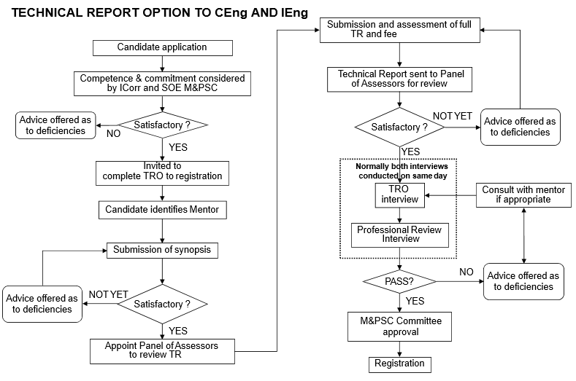

COMPLETING THE APPLICATION FORM

Application requires submission of the appropriate application form plus supporting documentation. It is important to complete all sections of the form in the space provided, even when you amplify certain sections in your CV. Your application must be printed or written in BLOCK CAPITALS. This form is also available in Word Format on the Institute’s website www.icorr.org.

Personal Details

Please complete all details, including your ICorr membership number and grade.

Engineering education & academic qualifications

Photocopied evidence of academic qualifications must be provided. Photocopies must be certified by your sponsoring referee as being true copies. A currently accredited Masters Level courses will be checked by Institute of Corrosion.

Criteria

Please complete these details fully giving details of your employer, showing your immediate superior and any staff who report to you. This should include any professional qualifications that they hold. This is the most important part of the application as it is against the information provided that the assessments of your experience and competences are made. Full details should be provided in your Portfolio and Professional Report as detailed below.

References

You must have a sponsoring referee who should be Fellows or Professional Member of the Institute of Corrosion. The referee should also be Chartered Engineers or if this is not possible CChem or CPhys. (in exceptional cases, professional members of other engineering or scientific Institutions may be acceptable as a referee). Your referee should attest the application and supporting documentation wherever possible prior to submission and may also be requested to provide a confidential reference.

Undertaking

You and must sign the declaration statements at the end of your application form
and your sponsoring referee must attest all supporting documentation.

Personal Professional Report (Portfolio / CV)

All Chartered Engineers are required to create and maintain a detailed Professional Report. The Individual Professional Report will demonstrate your career progression. You should provide information regarding your initial period of training and experience to demonstrate the extent of your knowledge of corrosion engineering, prevention or control including length of time you have been working at a level of responsibility appropriate to a Chartered Engineer and the degree of responsibility held.

This will clearly set out education and work experience gained with dates. It must identify the relevant tasks, level of responsibilities and name(s) of Supervisor(s). Further each entry should be counter-signed by an appropriate person who has a personal knowledge of the Candidate’s work, such as the Supervisor, employer.

Please use the following format as demonstrated in the example Report
Date
Position/responsibilities
Type of Work
Supervisor(s)
Training undertaken
Tasks
Criteria No – Use the numbers corresponding to the Criteria for Chartered Engineer (p3) of the Application Form. You may add further detail if required for clarifying how the task met the requirement(s).

It is only necessary to list Tasks relevant to the Criteria for Chartered Engineer (see Appendix A).

Please:
- Enclose with the Professional Report copies [NOT originals] of certificates – these should be signed by the Candidate and initialled if appropriate by the Referee.
- Provide a list of abbreviations.
- The Personal Professional Report is a central part of the assessment and as such a .;CV in lieu is not acceptable.
- The PPR has a pro forma title page.
- The PPR must clearly show engineering related training, responsibility etc. The PPR might typically outline the project/problem – set out hypothesis and methodology [consider the use of alternative methodologies] – describe test results and their analyses – outline refinement of hypothesis – [speculate on application of engineering knowledge gained]. The Candidate must clearly show his/her roles and responsibilities for each project.
- The PPR should be 12–15 pages in length of A4 and each page should be numbered..

You must sign your Personal Professional Report under the statement:
“I certify that this Personal Professional Report is a true and accurate statement.”

Your sponsor must attest your Personal Professional Report under the statement:
“I certify that I have read the Personal Professional Report of (your name) and confirm that, to the best of my knowledge, it is a true and accurate statement.”

The Case Study

As part of the Personal Professional Report a case study, for which you were responsible, shall be included. The purpose of the case study is to give an example of your work and will be used by the Review Panel for assessing your application.

You are requested to select a project, or a number of small projects, which will demonstrate the range of your experience, technical ability and depth of responsibility.

A suggested format for a report would be:

Synopsis

Background (which could include details such as how potential projects are identified, how project proposals are prepared, how you were allocated the task, size of project)
Technical content (which could include details such as planning the project, methods and techniques used, technical and budgetary constraints, and your management of the project)
Outcomes (the implications and applications of the project)

It is essential that you clearly identify your own role in the project by writing in the first person singular, and that you clearly bring out the corrosion engineering, prevention or control relevance. If you do not clearly spell out your own contribution it might be assumed that the project was not fully your responsibility and you may not be given full credit for your work.

You should ensure that the case study demonstrates awareness of the scientific principles of the work described and highlights your own scientific competence.

Your Case Study should be no longer than 5 sides of A4 must be submitted as a single sided document and each page must be numbered. Please also ensure that you have obtained any necessary permission from your employer for the use of the Case Study. In the event of the Study being commercially sensitive, please seek advice from the Qualifications Secretary.

You must sign your Case Study under the statement:
“I certify that this Case Study is a true and accurate statement.”

Your sponsoring referee must attest your Case Study under the statement:
“I certify that I have read the Case Study of (your name) and confirm that, to the best of my knowledge, it is a true and accurate statement.”

APPLICATION COMPLETION

On completion of the application, please ensure that it has been attested by your sponsoring referee if possible and that all the required documentation is attached. Incomplete documentation will delay the progress of your application or even cause rejection. Send complete submission to:
Institute of Corrosion
Corrosion House,
5 St Peter’s Gardens
Marefair
Northampton, NN1 1SX

THE SELECTION PROCESS

On receipt of the completed application and supporting documents, the application is given a unique number for tracking purposes. The application is scrutinised by the EC Registration Committee to ensure that all relevant information has been provided and the Candidate is a fully paid up Professional ember of the Institute of Corrosion. The referee may be requested to submit a confidential reference.

On acceptance, the documents are then sent to the EC Registration Committee for processing by them in accordance with the procedures. If the application is considered satisfactory, it is sent to the Society of Operations Engineers Membership and Professional Standards Committee for affirmation of the assessment and then the Candidate will be invited to attend an interview by a review panel including at least one specialist corrosion engineer from the field of expertise of the Candidate.

APPENDIX A

PROFESSIONAL COMPETENCES WHICH NEED TO BE DEMONSTRATED

FOR THE AWARD OF CHARTERED ENGINEER

A Professional Member must be able to prove his/her competence by virtue of his/her initial training and experience and throughout his/her working life to:

- Optimise the application of existing and emerging technology because of your specialist understanding of corrosion engineering, prevention or control and a broad knowledge of engineering principles | A1 | Ensure that his/her knowledge and understanding of corrosion engineering, prevention or control is firmly based and that he/she is able to contribute to emerging technology.
 | A2 | Demonstrate competent practice of experimental corrosion engineering, prevention or control technology.
 | A3 | Ensure that knowledge of related disciplines is developed and maintained so that opportunities to exploit existing and emerging technologies are appreciated.
 | A4 | Be able to exploit emerging technologies which impinge on corrosion engineering, prevention or control
 | A5 | Promote innovation and technology transfer.
- Apply appropriate theoretical and practical methods to provide a creative problem solving approach to scientific problems. | B1 | Identify potential projects and opportunities
 | B2 | Undertake research to enable appropriate solutions to these scientific problems to be selected for further development.
 | B3 | Plan and deliver solutions considering cost, benefits, safety, quality, reliability appearance and environmental impact.
 | B4 | Evaluate the solutions and make improvements.
- Provide technical, commercial and managerial leadership. | C1 | Prepare project proposals.
 | C2 | Manage projects including planning, budgets, control, people and resources.
 | C3 | Develop the capabilities of staff to meet the demands of changing technical and managerial requirements.
 | C4 | Support continuous improvement by quality management.
 | C5 | Understand the employing organisation’s strategy and mission statement and how this is put into practice by the company structure.
- Use effective communication and interpersonal skills | D1 | Work and communicate with others at all levels.
 | D2 | Effectively present and discuss ideas and plans.
 | D3 | Develop team-working skills
- Make a personal commitment to live by the appropriate code of professional conduct, recognising obligations to society, the profession and the environment. | E1 | Comply with the codes and rules of conduct of the SEE and the Institute of Corrosion
 | E2 | Manage and apply safe systems of work
 | E3 | Undertake engineering work in compliance with the codes of practice on risk and the environment
 | E4 | Carry out the continuing professional development necessary to ensure competence in the areas of future intended practice.
 | E5 | Exercise responsibilities in an ethical manner.

These are expanded on the following pages.
A. Optimise the application of existing and emerging technology because of your specialist understanding of corrosion Engineering, prevention or control and a broad knowledge of scientific principles. Chartered Engineers will:

A.1 Ensure that his/her knowledge and understanding of corrosion engineering, prevention or control is firmly based and that he/she is able to contribute to emerging technology. This includes the ability to:
  - Develop and use an understanding of the relationships that exist amongst composition, structure, properties and processing to optimise all relevant applications.
  - Contribute specialist knowledge of corrosion engineering, prevention or control to the development of production, fabrication and any other manufacturing processes.
  - Identify personal technical weaknesses and use all appropriate resources to overcome them.
  - Increase their own personal knowledge base through research, experimentation and information retrieval.

A.2 Demonstrate competent practice of experimental corrosion engineering, prevention or control technology. This includes the ability to:
  - Prepare samples for examination and testing with an appreciation of the importance of appropriate sample locations.
  - Select and use appropriate characterisation techniques, including performance testing, micro-structural and chemical analysis, and to interpret and report on the findings.
  - Recognise the uses, advantages and limitations of relevant equipment, control systems and procedures.
  - Understand the importance of national and international standards, the controls necessary to obtain reliable results and the associated uncertainties.

A.3 Ensure that knowledge of related disciplines is developed and maintained so that opportunities to exploit existing and emerging technologies are appreciated. This includes the ability to:
  - Interpret the information contained in technical drawings
  - Apply a range of engineering knowledge to technical problems
  - Understand the application of computers in design, manufacture and as components of products
  - Participate in the design process and take a lead in the selection and use of materials/processes
  - Extend knowledge of related disciplines or fields and encourage co-operation across discipline boundaries so that emerging technology is readily applied.

A.4 Be able to exploit emerging technologies, which impinge on corrosion engineering, prevention or control. This includes the ability to:
- Assess the potential impact of emerging technologies on the production, processing and use of corrosion engineering, prevention and control processes.
- Develop and maintain an understanding of the role of information technology and how it can change products or processes.
- Use all available information sources to be aware of technological developments in corrosion engineering, prevention and control and other emerging technologies.
- Evaluate the potential impact of new technologies in terms of any manufacturing process on product design and life cycle including recycling and environmental issues.

A.5 Promote innovation and technology transfer. This includes the ability to:
- Investigate needs and exploit opportunities for the transfer of existing and emerging corrosion engineering, prevention and control technologies.
- Assess user acceptance of and the future requirements for new and improved materials, minerals or mining technologies and/or processes.
- Share knowledge and emerging technology with partners within a supply chain
- Identify areas suitable for collaborative research and take responsibility for initiating joint activity.
- Apply new engineering principles to aid any advanced engineering designs.
B Apply appropriate theoretical and practical methods to provide a creative problem solving approach to scientific problems. Chartered Engineers will:

B.1 Identify potential projects and opportunities. This includes the ability to:
- Review external developments to assess applicability and areas of responsibility
- Continually review the potential for enhancement of products, materials and services
- Identify the complexities of potential projects and the problems associated with them.
- Exercise original thought in synthesising potentially satisfactory outcomes to scientific challenges.

B.2 Undertake research/development to enable appropriate solutions to these engineering problems to be selected for further development. This includes the ability to:
- Identify and agree customer, user and community requirements.
- Appreciate the application of experimental design, mathematical and process models as tools to aid the development of solutions.
- Assess the limitations materials or processes impose on potential designs, manufacture and performance of components or of process /production plant.
- Undertake cost benefit and risk analysis, feasibility studies and life cycle costing to achieve project goals.
- Analyse promising concepts to determine appropriate solutions, assessing the impact of factors such as performance, reliability, product life and customer satisfaction.

B.3 Plan and deliver solutions considering cost, benefits, safety, quality, reliability appearance and environmental impact. This includes the ability to:
- Prepare and implement documented proposals that consider cost, safety, reliability and environmental impact.
- Specify test schedules for materials performance and provide analysis of test results that contribute to achievement of project goals.
- Organise industrial trials that contribute to the improvement of the product or process.
- Identify possible problem areas and negotiate modifications or adaptations as necessary.
- Take corrective action to overcome any shortcomings revealed by trials.
- Ensure that targets for completion of component parts of a project are met.
- Deliver materials, specifications or products to meet customers’ requirements.

B.4 Evaluate the solutions and make improvements. This includes the ability to:
- Discuss with all interested parties the evaluation of products or processes.
- Evaluate solutions against the project specification.
- Identify potential improvements and ensure that they meet the specification, are practical and are implemented.
B.4.3 Prepare or understand how materials specifications are arrived at

C provide technical, commercial and managerial leadership. Chartered Engineers will:

C.1 Prepare project proposals. This includes the ability to:
- Prepare and agree the developments of a project proposal.
- Negotiate adequate resource provision.
- Determine methods of approach and analysis work to be performed to provide the basis for resource estimates, applying appropriate project management techniques.
- Prepare and submit tenders for research or development programmes.

C.2 Manage projects including planning, budgets, control, people and resources. This includes the ability to:
- Set and implement work objectives and priorities, including time, resource and cost estimates.
- Exercise leadership and organise work teams.
- Set and control budgets for projects.
- Monitor tasks to ensure activities are performed to time and within budget and take corrective action as required.
- Recognise, interpret and apply appropriate standards and regulations.

C.3 Develop the capabilities of staff to meet the demands of changing technical and managerial requirements. This includes the ability to:
- Contribute to identifying and determining educational and training needs.
- Develop training plans for others.
- Implement experimental development programmes for others, including workforce retraining, adaptation to new technology and skills extension tasks.

C.4 Support continuous improvement by quality management. This includes the ability to:
- Demonstrate knowledge of reliability and how this may be applied to the maintenance of equipment.
- Contribute to the implementation of a quality system.
- Foster the acceptance of quality management principles.
- Apply company, national and international standards to quality control and quality assurance.

C.5 Understand the employing organisation’s strategy and mission statement and how this is put into practice by the company structure. This includes the ability to:
- Be aware of the contributions made by all the departments to the operation of the organisation and how these are measured against organisational objectives and values.
- Demonstrate an awareness of employment law, role of trade unions and their relationship to management.
- Be aware of the organisation’s competitive position and have technical and commercial knowledge of its processes, products and competitive technologies.
- Be aware of the financial constraints within which the organisation operates.

D Use effective communication and interpersonal skills. Chartered Engineers will:

D.1 Work and communicate with others at all levels. This includes the ability to:

Communicate effectively in the English language.

Develop good working relationships.

Take part in discussions ensuring two way effective communication.

Liaise and negotiate with colleagues, customers and experts within and beyond the organisation. Respond effectively and efficiently to all received communication.

D.2 Effectively present and discuss ideas and plans. This includes the ability to:

Clarify objectives, identify main purpose and select appropriate media for communication.

Prepare professional level presentations, lectures, reports and published papers.

Select appropriate methods of communication using words, images, audio and visual aids as appropriate.

Communicate fluently in written and oral presentations at an experienced professional standard.

Understand the need to preserve intellectual property rights for the employer in any external communication.

D.3 Develop team working skills. This includes the ability to:

Identify and work towards collective goals and responsibilities.

Create, maintain and enhance effective working relationships.

Issue clear and accurate instructions as appropriate.

Develop teams, individuals and self to enhance performance.

Undertake negotiations, conflict resolution and mentoring.

E Make a personal commitment to live by the appropriate code of professional conduct, recognising obligations to society, the profession and the environment. Chartered Engineers will:

E.1 Comply with the codes and rules of conduct of these and the Institute of Corrosion. This includes a commitment to:

E.1.1 Comply with the obligations for health, safety and environmental protection in relation to both organisational and legislative requirements and must be aware of the purpose of the legislation and be prepared to respond to future legislative demands.

E.1.2 Place responsibility for the welfare, health and safety of the workforce and wider community at all times before responsibility to the profession or other sectional interests.
E.1.3 Comply with codes of conduct.
E.1.4 Apply professional skill in the interests of employer or client for whom they act in professional matters, as a faithful agent or trustee
E.1.5. Give evidence, express opinions or make statements in an objective and truthful manner and on the basis of adequate knowledge.

E.2 Manage and apply safe systems of work. This includes a commitment to:

E.2.1 Take account of potential professional risks and liabilities, and accept responsibility for them.

E.2.2 Implement appropriate occupational health and safety requirements.

E.2.3 Investigate community safety requirements and act to solve any incipient safety problems related to corrosion engineering, prevention and control processes.

E.2.4 Take appropriate precautions when dealing with hazardous operations or materials.

E.2.5 Take account of disaster prevention, mitigation and recovery methods.
E.2.6 Advise manufacturing areas and customers of material hazards.

E.3 Undertake engineering work in compliance with the codes of practice on risk and the environment. This includes a commitment to:
E.3.1 Promote the actions required in engineering practice to improve, sustain and restore the environment.
E.3.2 Promote the wise use of non-renewable sources through waste minimisation, recycling and the development of alternatives wherever possible.
E.3.3 Strive to achieve the beneficial objectives of engineering work with the lowest possible consumption of raw materials and energy and by adopting sustainable management practices having due regard to risk issues.
E.3.4 Take account of total life-cycle implications of products and projects in relation to risk and environment.

E.4 Carry out the continuing professional development necessary to ensure competence in their areas of future intended practice. This includes a commitment to:
E.4.1 Set goals to achieve personal and organisational objectives.
E.4.2 Prepare and maintain a career action plan.
E.4.3 Undertake professional development to enhance technical and management competence.
E.4.4 Maintain records of professional development activities.

E5 Exercise responsibilities in an ethical manner.

Apply ethical principles to all areas of working life.

Appendix B - Competence & Commitment Checklist (CEng)

We ask that you assess yourself, preferably with your mentor or sponsor, against the criteria below before you start making your application. This will show you whether you are likely to meet the requirements for CEng. The table below contains a condensed breakdown of the Institute’s requirements, with tick boxes, to help you in your assessment. You should refer to the full list of competence and commitment statements provided in Appendix A for more information regarding specific areas. You must be able to meet the majority of the requirements at a good or expert standard before you complete your application. You may wish to gain further experience in areas where you feel you have only ‘some knowledge.’ If you tick more than two boxes as ‘little or no knowledge’ you should do further study or gain more experience before application.

As a Chartered Engineer you must be competent by virtue of your initial formation and professional development and throughout your working life to:
 |  | Expert | Good knowledge | Some  knowledge | Little /no knowledge
- Optimise the application of existing and emerging technology because of your specialist understanding of corrosion engineering, prevention or control and a broad knowledge of scientific principles | Knowledge and understanding of corrosion engineering, prevention or control.
 | Practice of experimental corrosion engineering, prevention or control technology.
 | Knowledge of related disciplines is developed and maintained
 | Exploit emerging technologies
 | Promote innovation and technology transfer.
- Apply appropriate theoretical and practical methods to provide a creative problem solving approach to scientific problems. | Potential project identification
 | Research of possible solutions
 | Planning & delivery of solutions
 | Evaluation of solutions
- Provide technical, commercial and managerial leadership. | Preparation of project proposals.
 | Project management
 | Staff development
 | Continuous improvement
 | Knowledge of the organisation’s structure & mission statement
- Use effective communication and interpersonal skills | Working & communication with others
 | Presentation & discussion skills
 | Team working skills

 |  | Expert | Good knowledge | Some  knowledge | Little /no knowledge
- Make a personal commitment to live by the appropriate code of professional conduct, recognising obligations to society, the profession and the environment. | Knowledge & use of codes & rules of conduct
 | Knowledge & use of safe systems at work
 | Knowledge & use of codes of risk and the environment
 | Continual Professional Development
 | Exercise responsibilities in an ethical manner

