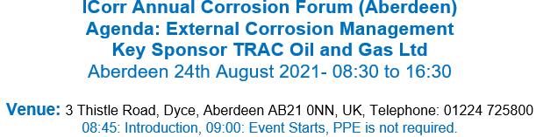

Title ... ... ..... Name ... ................. .. ....... ...... ..... ... .... ............ ...... ............ ............ .. ... .................... ..
Organisation .... ... ... .................. ... ...... ..... .. .... ... ......... .... ......... . ...... .. .. . ..... ...... . .. .. ....... ....... ..
Address .... ... ... .................. ... ...... ..... .. .... ... ......... .... ......... . ...... .. .. . ..... ...... . .. .. ....... ......... .......
Postcode .... ... ... ..................
Telephone ... ... . .. ........... ........ ... ..... ... ........ ...... . ... email ... .. .. ........... ... ..... ...... ...... ... ... ..... .......

A full-day course, comprising of a number of lectures covering different aspects of external corrosion, providing basic information on external corrosion principles, mitigations, inspections, risk management and few case studies:
- The objective of this course is to improve understanding of external corrosion mechanism, mitigation and to raise awareness of external corrosion management.
- The lectures are provided on voluntary basis by renowned corrosion engineers / scientists.
- Target audience is: graduate engineers, non-corrosion engineers and others working closely with corrosion, (e.g. integrity engineers, inspection engineers, etc. ).
- The course is hosted by ICorr Aberdeen through kind assistance of its local / national sponsors.

Conference Tickets are £75.00 + VAT.
- To Apply: please email completed form to: admin@icorr.org
- Spaces are strictly limited and will be allocated on a ‘first-come first-served’ basis.

I hereby consent to the Institute of Corrosion using and processing my personal data for the purposes required by the Institute of Corrosion as set out on this form.

Yes I No Signed.... ... ...... .. ... .... .. ....... . ........... .. .. .. ... ...... ...... ... Date . . . . .. . .. .. ........ . ............ .... ... .. .

Payment
The cost of attending the meeting will be £75+VAT. Please note that it is not possible for ICorr to invoice you for the meeting fee. Please send cheques to the address below payable to "Institute of Corrosion" or alternatively enter card details below. Advanced booking is required.

Corrosion House, 5 St Peters Gardens, Marefair, Northampton, NN1 1SX, United Kingdom

Credit Card Authorisation
Please debit my Credit/Debit Card Name on card ..... ........ .. ....... .. ... .... .... ........... ...... .. . ........ ...... ...... ...... ... .

Card Number

Expiry Date

3 Digit Security No.

Signed ........ .. ..... ... .. .... ... .. ..... ...... ...... .. .... .. .. . Member: Yes / No
Membership Number .. .... ..... . ... . .... .. .... .. ... .... .... .

