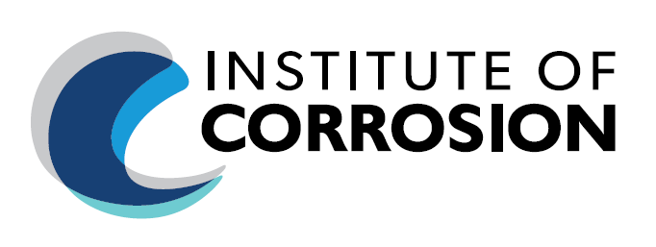

ICorr Wales & South-West England Branch
Mott MacDonald, 10 Temple Back, Bristol, BS1 6FL

Thursday 19th September 2024, Start Time: 17:30pm (UK Time)

In-Person Presentation only.

For Registration (use LINK below):

Event Registration
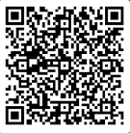

Event is Free of Charge to attend.
Selection of cathodic protection systems for reinforced concrete structures
&
A pathway to thickness measurement locations (TMLs) digitalisation.

Speakers: Dr. Rene Brueckner, Mott MacDonald
Erik Fabre, Inductosense

Event Programme:
17.30 – 18:00: Arrival / Networking / Refreshments
18:00 – 18:10: Introductions
18:10 – 18:40: Selection of cathodic protection systems for reinforced concrete structures
18:40 – 19:10: A pathway to thickness measurement locations (TMLs) digitalisation.
19:10 – 19:20: Q&A
19:20 – 20:00: Networking / Depart

The Talks:
Selection of cathodic protection systems for reinforced concrete structures

Cathodic protection is a corrosion management strategy for deteriorating reinforced concrete structures or it can be used as preventative measure in situations where corrosion may be expected during the service life as a result of the environmental exposure conditions. The technology has advanced over time. There are now a number of different systems that can conveniently be considered in three categories, including impressed current cathodic protection (ICCP), hybrid cathodic protection (HCP), and galvanic cathodic protection (GCP).

The selection of the most suitable cathodic protection system is dependent on various factors that include technical applicability, environmental impact, sustainability, health, safety and wellbeing and whole-life costs. The system with the lowest whole-life costs may not be the most sustainable and environmentally friendly solution over the whole life when the weighting of non-technical aspects is increased during such an assessment. In recent years there has been a significant push in the UK from authorities to improve sustainability, reduce the environmental impact and risk to health, safety and wellbeing in addition to mainly assessing construction and operation costs and technical applicability.

The presentation will give an overview of the various systems and their advantages and disadvantages to inform the option selection process with a focus on sustainability and environmental impact.

Graduating with a Diplom-Ingenieur in Civil Engineering with specialisation in material science from the Bauhaus University Weimar, Germany in 2003, and a PhD about structural effects of the thaumasite form of sulfate attack from the University of Birmingham in 2008. Rene joined Mott MacDonald’s Materials and Corrosion Technology Department in Manchester in 2007 and now leads the Materials and Corrosion team in the Bristol office. He is a chartered and European engineer and member of the Institute of Corrosion. He has been involved in condition assessments of reinforced concrete and steel structures, design and monitoring of cathodic protection systems, durability assessments, forensic engineering, and is generally interested in materials that are grey and crack or are corroding. He is also an associate editor of the ICE Construction Materials and Engineering History and Heritage journals and an active member on several RILEM technical committees. | 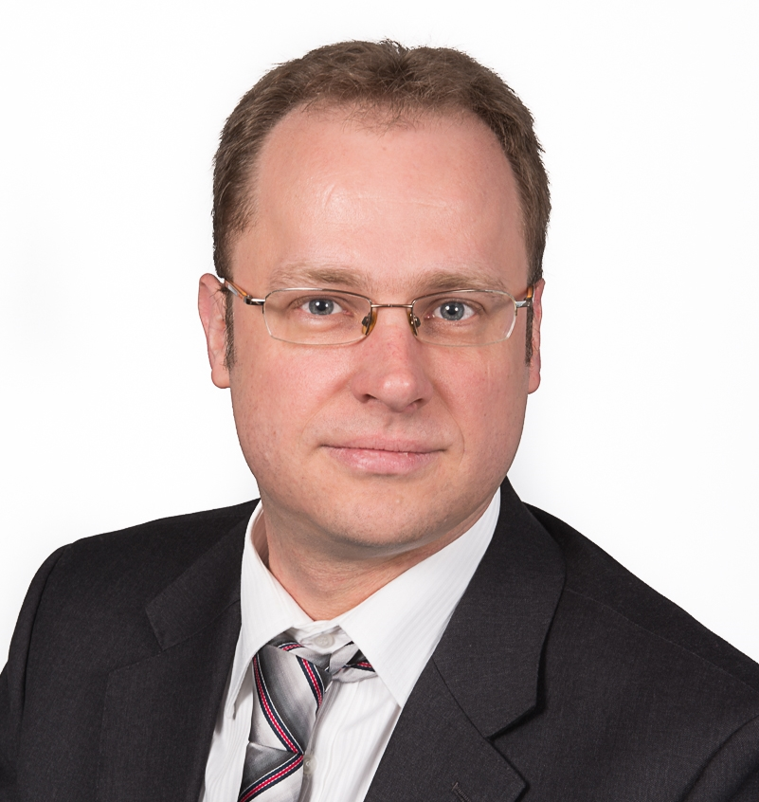
A pathway to thickness measurement locations (TMLs) digitalisaiton.

Permanently installed sensors provide more accurate results compared to conventional inspection due to their consistent positioning and coupling. However, due to their cost, they are normally used for monitoring critical areas for corrosion rate estimation. There are hundreds of thousands of thickness measurement locations (TMLs) on the site, making it challenging to monitor all of them.

We propose an alternative approach that combines passive sensors and a different data collection method to enable a cost-effective, consistent, and deployable solution. In this work, we present how the handheld data collector, robotics, and online solutions work together to address different applications with accessibility and inspection frequency.

Erik Fabre is the head of R&D projects at Inductosense. Inductosense are a UK-Based technology developer, specialising in ultrasonic solutions for monitoring internal corrosion and erosion. Erik has a Master’s in Engineering with 8 years of experience in the industry. Erik’s expertise focuses on ultrasonic testing and sensors, supporting multiple clients with technology projects and sensor deployments. | 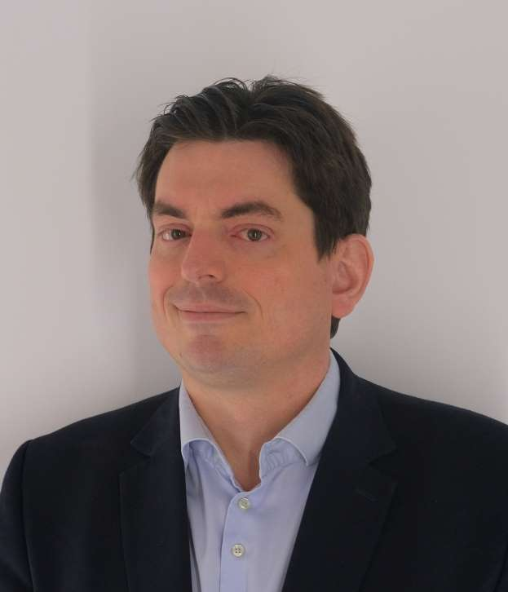

Additional Information:

- Registration information will be shared with our Branch volunteers to help facilitate the event.

For Continuing Professional Development (CPD) or to join our Mailing List,
request by email to: swchair@icorr.org

Instutute Professional Memberships are available at: https://www.icorr.org/grades-and-benefits-of-individual-membership-2/

Free Student Memberships are available at: https://www.icorr.org/free-student-membership/ [icorr.org]

